**Synopsis**

**On**

**ROOM ON RENT**

**(HOTEL SERVICE SYSTEM)**

**by**

VINAY KUMAR BHARDWAJ (2100290140149)

SANYA RASTOGI (2100290140116)

DUSHYANT (2100290140063)

**Session:2022-2023 (4th Semester)**

Under the supervision of

**Prof. Mr. Praveen Kumar Gupta**



### **Department Of Computer Applications**

**KIET GROUP OF INSTITUTIONS, DELHI-NCR, GHAZIABAD-201206**

(march- 2023)

# ABSTRACT

This is a website of room on rent hotel service system which can be used by customer to reserve hotel rooms, read about hotel, check gallery. this website of hotel removes the hectic task of customer and executive for searching and booking rooms in hotel.

This system will help the administrative staff that is executive of the hotel to keep the daily and the history record details of the customers in proper database.

The system aims at the maintenance and management of the Hotels that are available in the particular Hotel It mainly takes care of the Hotel management at the core area of the database. The system provides the information regarding the Hotels that are available and their status specific to availability. The guests can visit the site with the required information that is expected by the system. Each registered guest can raise a request for the unit bookings. The Guests are scheduled with the information of the availability of the units for they have requested the time.

The total front end was dominated using HTML standards applied with the dynamism of PHP. The communicating client was designed using PHP At all proper levels high care was taken to check that the system manages the date consistency with proper business validations. The database connectivity was planned using the MySQL Data Base Connectivity, the authorization and authorization was cross checked at all stages. The user level accessibility has been restricted into two zones the administrative and the normal user zone.

**TABLE OF CONTENTS**

1. Introduction 2
2. Literature Review 3
3. Project / Research Objective 4
4. Project Modules 5
5. Project / Research Outcome 6
6. Proposed Time Duration 7
7. References 8

# INTRODUCTION

Room on rent hotel service system is a application software where the management of entire hotel is computerized. The room on rent hotel management system is designed using PHP as the rich GUI for frontend and MySQL Server as the secured backend database.

In this project the details are maintained like customer details, reservation details, booking details and billing details The reservation process of reserving rooms for the customers, cancelling the reserved rooms, booking the rooms, vacating the rooms, the restaurant management, billing process, etc. all are computerized, and the management is done without any difficulty.

In this website hotel bookings and rooms make this system very flexible and convenient. The hotel manager is a very busy person and does not have the time to sit and manage the entire activities manually on paper. This application gives him the power and flexibility to manage the entire system from a single online system. Hotel management project provides room booking, staff management and other necessary hotel management features. customers can view and book room online. Admin has the power of either approving or disapproving the customer’s booking request. Other hotel services can also be viewed by the customers and can book them too.

The reports can be viewed completely and the head of the management daily or weekly or monthly can review it. For company auditing it will be more useful. This Proposed System will be interactive, faster and user-friendly for the end users. Using the hotel management system, the following activities can be performed.

* Room Service
* Check In
* Check Out
* Staff Master
* Staff Attendance
* Login

3

# Literature Review

* 1. **What is room on rent hotel service system?**

Room on rent hotel service system just like a hotel management is about overseeing every operation of the property. This requires knowledge of distribution strategy, finance, customer service, staff management, marketing, and more.in no way should any of these be treated as ‘set and forget’. Hotel management is about constantly evaluating performance is every facet of the business and making necessary adjustments.

Ultimately effective hotel management will not only ensure your hotel stays in business, but is able to profit and grow over time. Think of the hotel as an ecosystem that will get healthier the better you manage it. As your hotel becomes more successful you can upgrade and charge higher rates, pay staff higher wages, and create an experience that guests want to come back for.

It can take time to get everything right however. There are many skills you’ll already possess but many others you need to learn along the way, or else hire staff that can provide the knowledge for you

# How does room on rent hotel management work?

The mission is to facilitate easy management and administration of a hotel with capabilities to do Booking or reservations of the rooms, Cancellation of the rooms, Cash billing, Room service, Restaurant service, Restaurant billing, Total billing, Travels arrangement etc. using the automated room on rent service hotel management software. One can keep detailed records or info on an unlimited number of customers. The system lets the user know which all rooms are available for occupancy at any point of time. This makes the booking considerably faster. And thus helps the hotel in better management and reduce a lot of paperwork as well as manpower.

4

1. **Project Objective**

During the past several decades personnel function has been transformed from a relatively obscure record keeping staff to central and top-level management function. There are many factors that have influenced this transformation like technological advances, professionalism, and general recognition of human beings as most important resources.

* + - A computer-based management system is designed to handle all the primary information required to calculate monthly statements. Separate database is maintained to handle all the details required for the correct statement calculation and generation.
    - This project intends to introduce more user friendliness in the various activities such as record updating, maintenance, and searching.
    - The searching of record has been made quite simple as all the details of the customer can be obtained by simply keying in the identification of that customer.
    - Similarly, record maintenance and updating can also be accomplished by using the identification of the customer with all the details being automatically generated. These details are also being promptly automatically updated in the master file thus keeping the record absolutely up-to-date.
    - The entire information has maintained in the database or Files and whoever wants to retrieve can’t retrieve, only authorization user can retrieve the necessary information which can be easily be accessible .
    - The main objective of the entire activity is to automate the process of day-to-day activities of hotel like:
      * Room Service
      * Check In
      * Check Out
      * Staff Master
      * Staff Attendance
      * **This project has some more features:**
    - System Connectivity
    - No data duplication
    - No Paper Work Required
    - Automatic data validation
    - User friendly environment
    - Data security and reliability
    - Fast data insertion & retrieval
    - Easy performance check
    - Time Efficien

4

# Project Module

## 4.1 Reservation Module

This module deals with reservation enquiry and reservation. During reservation, the details of the customers, type of room required and number of rooms required are fed in to the system. Once these in formations are entered, the system searches for the unoccupied rooms and displays the result. In reservation enquiry, customer can get the information such as rent of rooms and details of rooms available.

## 4.2 Check In/Check-out Module

This module deals with the reservation check-in (i.e., allocating room for the customer who has already reserved) Direct check-in (i.e., checking in without reservation), handling checkout of guest and Bill payment.

## 4.3 Bills and Payments Module

This module deals with the generation and tracking of bills and payments made by the guest. The bills are classified into lodging bills and Restaurant Bill. The lodging bill is calculated using the check in and checkout details of the person. The Restaurant bill is generated based on the food items consumed by the guest during his stay in the hotel.

## 4.4 Reports

This module deals with the generation of the reports for the various modules. The customer list can be generated. Room status list can be retrieved for reference. The check in and checkout registers can also be retrieved for any future queries.

5

# Project Outcomes

Hotel management system is an application software and this website have done work in two parts first is User Zone and second is Admin-Zone. in user zone user can avail different types of facilities by visiting this website like:

## 5.1 User Zone:

1. Types of Room
   1. Superior room
   2. Deluxe room
   3. Guest room
   4. Single room 2- Bedding Type
2. Single
3. Double
4. Triple
5. Quad
6. None 3- Meal Plan
7. Room Only
8. Breakfast
9. Half Board
10. Full Board

4- Check in and check out

## 5.2 Admin-Zone:

Second is Admin-Zone here admin can confirm room booking, generate payment report, he can see rooms status and admin can see monthly wise rooms profit so that he can find out how much profit the hotel made in a month.

6

# Proposed Time Duration

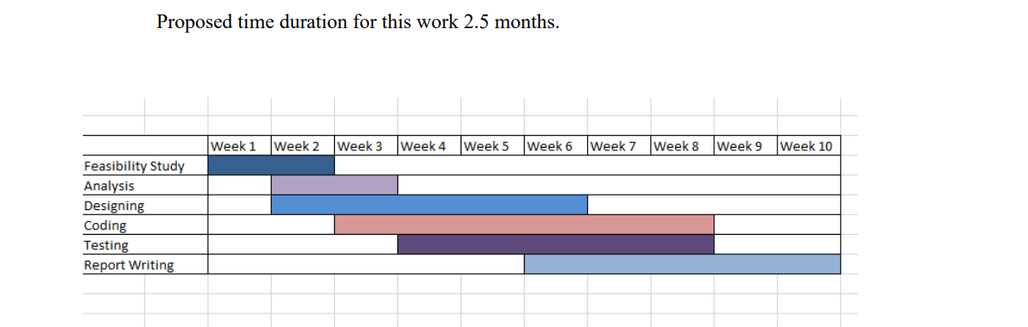

7

# References

## 7.1 Book References:

1. PHP Programming McGraw Hill Education
2. PHP Projects Tony Martin, Dominic Selly
3. PHP Professional Projects Kuljit Kaur, Pooja Bembey
4. MY SQL The Complete Reference George Koch

## 7.2 Internet References:

1. [**https://**[**www.softwareadvice.com/hotel-management/**](http://www.softwareadvice.com/hotel-management/)]
2. [[**http://www.high-level-software.com/features/**](http://www.high-level-software.com/features/)]
3. [**https://**[**www.scribd.com/doc/153679335/SRS-Hotel-Management-System**](http://www.scribd.com/doc/153679335/SRS-Hotel-Management-System)**]**

8